NDEJJE  UNIVERSITY
KAMPALA CAMPUS

FACULTY OF SCIENCE AND COMPUTER STUDIES.
TINAH BRIDAL SPOT BOUTIQUE MANAGEMENT SYSTEM

NAME | REG.NO
KASORO CHRISTIAN | 25/2/370/W/1210
ZZIWA ABDURAHUMAN | 25/2/370/W/2495
KIIZA BOBSON | 25/2/370/W/1744
MUKEMBO JESSE | 25/2/370/W/431

COURSE UNIT: SOFTWARE PRINCIPLES 2
COURSE : BSE
YEAR : ONE
SEMESTER : TWO
LECTURER : MR LUYIMA ALEX
Date: 27th March 2026.

1.Executive summary
Tinah bridal spot is a small boutique located in Kampala, in a Jemba plaza along luwum street, specializing in rental and sale of traditional women’s attire (gomesis, mushananas) for cultural events such as but not limited to traditional weddings. The business is run and owned by a single owner who employs one full time shop attendant.
The boutique currently relies on a manual transaction book for sales, rentals, customer payments and inventory management. This manual approach has led to recurring financial irregularities, unverified customer payment disputes and inconsistent stock tracking and absence of a standardized pricing.
This report proposes the development of a Boutique Management System (BMS)- that will digitalize transaction recording, automate receipt generation, support basic inventory tracking and produce daily financial summaries.

2. Project Background and Context
Despite operating in a vibrant and growing market, the business manages transactional and operational records using a single physical transaction book and a simple receipt book. This has become a source of operational risk as the volume of transactions and customer base grows. The owner and employee identified record keeping as a critical area in need of improvement.

3. Problem statement
3.1 Formal Problem statement
Tinah Bridal Spot currently manages all sales, rental, inventory and financial records using a paper-based system. This system is challenging to maintain, with transactions frequently unrecorded. As a result, the business experiences financial discrepancies, and is sometimes unable to verify evidence, cannot accurately determine profit or loss and has no reliable means of tracking inventory. The failures have resulted into financial loss, customer distrust and operational inefficacy.

3.2 Problem decomposition table
Table 1: Problem decomposition table – Tinah Bridal Spot.
# | Root cause | description | impact | Evidence
P-01 | Inconsistent transaction recording | Transactions- particularly balance payments and small transactions not entered in the book at time of sale | End of day cash totals don’t match recorded totals, causing discrepancies. | Confirmed by Ms. Yuditah(attendant) during an interview: multiple excess or deficit identified.
P-02 | No-automated receipt generation | Receipts are handwritten and sometimes skipped for smaller transactions. There’s no backup record outside physical book. | Customer payment disputes | Ms. Nankya Justine (Owner) citied a dispute on Wednesday of that week as a direct consequence
P-03 | Non-standardized pricing | Prices are calculated per item on import costs and profit margin, but vary on mood, stock and bargain power | Inability to audit revenue accurately. | Business owner confirmed pricing is done in ranges rather than fixed amounts.
P-04 | Expenditure recording | Business cost- tailor fitting fees, food, delivery charges are irregularly recorded. | Reported money appears less than the actual money, preventing accurate profit loss calculation. | Ms. Yuditah listed unrecorded expenditures as a primary cause of end of day discrepancies.

4.Stakeholder Register
4.1 Identified stakeholders.
Table 2: Stakeholder register with Power/Interest Classification.

# | Stakeholder | Role | Power | Interest | Grid quadrant | Engagement strategy
S-01 | Business owner | Primary system user: approves all decisions | high | high | Manage closely | Regular consultation: demonstrates how the system reduces financial disputes and saves time
S-02 | Shop employee | Daily system operator: record transactions | Low | High | Keep informed | Hands on training: ensure the system is simple and doesn’t slow down service.
S-03 | Customers | Receive receipts: affected by dispute resolution | Low | Medium | Keep satisfied | Ensure receipts are clear, professional, and issued consistently for all transactions.
S-04 | Boda Boda delivery Riders | Carry out deliveries: maybe recorded in the system | Low | low | Monitor | Minimal engagement: only included if delivery tracking is added to scope
S-05 | Development team | Designs and builds the system | High | High | Manage closely | Regular internal reviews and progress checks to ensure alignment with requirements

4.2 Power/interest Grid
Based on the table above, the power/interest grid positions stakeholders as follows:
- Manage closely (High power, High interest): Business owner, Dev team
- Keep informed (Low power, High interest): Shop employee
- Keep satisfied (Low power, Medium interest): customers
- Monitor (Low power, Low interest): Boda boda delivery riders

5. Feasibility Study
The feasibility was assessed using 4 dimensions: Technical, Economic, Operational and Legal.

5.1 Technical feasibility
The proposed system is a C# console or windows Forms desktop application. The target hardware is a standard desktop or laptop computer, which the boutique already has access to and uses to watch the CCTV footage. No internet connectivity is required for the core system functionalities. Visual Studio Code and sharpdevelop IDE will be used to develop the program. No technical infrastructure is need beyond a PC running windows.

The core functions: transaction recording, receipt generation, inventory listing, and daily financial summaries.
Verdict: GO. The technical requirements are achievable within the client’s available infrastructure and the team’s competence.

5.2 Economic feasibility
The system will be developed at no cost to the client, as it’s a university project

Table 3: Cost-Benefit Analysis and Payback Estimate

Cost/Benefit Item | Estimate (UGX)
Development cost | UGX 0
Hardware (PC if needed) | UGX 800,000 (one time)
Printer for receipts | UGX 150,000(one time)
Total Estimated cost | UGX 950,000
Monthly benefit (Estimated loss prevention) | UGX 300,000+
Estimated payback period | Approximately 3-4 months

Verdict: GO. The solution is economically viable with the short payback period and minimal deployment cost.

5.3 Operational Feasibility
The boutique operates with 2 staff members: the owner and the shop attendant. Both stakeholders expressed desire for a digital recording system during the interview. The shop attendant, Ms. Yuditah, would be the primary daily user, acknowledged that the current system causes errors and she would welcome a system that automatically captures transactions and generates receipts.
Verdict: GO. Staff motivation is high and the operational environment supports adoption of a simple desktop system.

5.4 Legal Feasibility
No sensitive personal data beyond names (if included) and payment amounts is collected. Uganda’s Data Protection and Privacy Act (2019) requires that personal data be collected lawfully and for a stated purpose.
No special license or regulatory approvals are required to operate a transaction recording system for a small retail boutique.
Verdict: GO. The system operates within the bounds of the applicable Ugandan law.

6.Requirements Elicitation

6.1 Elicitation techniques used
Two elicitation techniques were employed during the project: Interviews and direct observation.
Below are interview notes developed from session with;
- The business owner (Ms. Nankya Justine)
Verbal consent to participate in the interview was obtained at the start of the interview on 26th March 2026 and a written signature as well.
Q.1: How do you determine the price of a gomesi?
A: “When I bring the clothes from Dubai, I look at Original price, the air ticket, the taxes I paid at customs, and I add my profit. But the prices aren’t fixed, we have price ranges. It also depends the stock I have.”
Q.2: Has there ever been a situation where a customer claims they paid but you don’t recall the transaction and they don’t appear in the records book?
A: “Yes, this has happened before, just of recent on Wednesday [26th March], a customer came saying they had paid but their name wasn’t in the book and they had a mobile money transaction message saying money was deposited on my number. So, we had to comply and assume it was our mistake.”
- Shop attendant (Ms. Nuwatekateka Yuditah)
Q.1: Tell me how a typical day is here at Tinah Bridal Spot from the start to the end of your day?
A: “Day begins with taking mannequins outside. I have to clean the floors, mop if needed, organize the place, and wait for customers, that’s about most of it.”
Q.2: How do you know what clothes you have in stock?
A: “We just know from experience because we are the ones who organize them in the displays, if you don’t see something, you check the book and see if it was rented out to a customer.”
Q.3: Has there ever been a situation where the money you have at the end of the day isn’t equal to what the book reports?
A: “it has happened before, it usually comes about when a customer pays a balance and it’s not recorded in the book, there will be a surplus, or when a gomesi is taken for fitting to the tailor and the expense is not noted, the money will be less, or when we buy lunch and the expenditure is not written down in the book. Sometimes customers also make small payments and we don’t even record them for example 50,000 or a 20K, those small moneys we might not record and at the end of the day, money is less.”
Q.4: if there’s anything you wish could have been done automatically, what would it be?
A: [Laughs] “Making money, but seriously, a system that records every single purchase or rent made and gives a receipt to the client automatically. It would be such a good thing.”
Q.5: In what ways do you reward customers who buy regularly?
A: “First of all every Saturday, we offer 20% off every attire bought and if a daily customer brings a new bride, they are given one free attire since a bride is a big package, with the bride, matrons and flower girls, so a regular brings a bride, they are given a free attire.”

6.2 Summary of Key Findings
Table 4: Elicitation Findings Summary
Finding ID | Theme | Finding | Source
F-01 | Financial Management | Transactions recorded inconsistently; end of the day cash not match book records | Ms. Yuditah Interview: Q.3
F-02 | Financial disputes | A customer payment dispute in March 26th 2026 could not be resolved from the transaction book alone | Ms. Justine – Interview: Q.2
F-03 | Pricing | Prices are not standardized: vary on mood, stock and bargaining power | Ms. Justine – Interview: Q.1
F-04 | Inventory | Stock is tracked by memory: no structured inventory count | Ms. Yuditah-Interview: Q.2
F-05 | Financial Management | Business expenditures inconsistently recorded, distorts profit picture. | Ms. Yuditah-Interview: Q.3
F-06 | Customer Management | Discounts and loyalty schemes applied manually with no tracking | Ms. Yuditah-Interview: Q.5
F-07 | System desire | Stakeholders independently requested automated transaction recording and receipt generation | Ms. Yuditah- interview: Q.4

6.3 Gender-Inclusive Elicitation Practice
Both primary stakeholders are female. In this interview, no gender imbalance was observed, both owner and employee participated freely and independently.

7. Elicited Requirements
7.1 Functional Requirements
Below is a table showing requirements traceable to a specific elicitation finding.
Table 5: Functional Requirements
FR-ID | Requirements Statement | Finding Ref.
FR-01 | The system SHALL allow a user record a new transaction by entering the name, transaction type (rental or sale), amount paid and customer name. | F-01
FR-02 | The system shall generate a numbered receipt automatically for every transaction, displaying the shop name, date item, amount and transaction type. | F-02
FR-03 | The system SHALL record business expenditures separately from sales, with a category, date and amount. | F-05
FR-04 | The system SHALL calculate and display a daily financial summary showing total income, total expenditure, and net balance for the day | F-01, F-05
FR-05 | The system SHALL a list of stock items, with name, quantity and status (available, rented out or sold) and update stock when rented out, returned or sold. | F-04
FR-06 | The system SHALL the user to search for a transaction by customer name or date to support payment dispute resolution. | F-02
FR-07 | The system SHALL allow the user to record a price calculation for a new item based on: purchase cost, air ticket price, taxes and profit margin. | F-03

7.2 Non-Functional Requirements
NFR ID | Category | Requirement statement | Acceptance Criterion
NFR-01 | Usability | The system SHALL present all menus and labels in plain English without technical jargons, so that a non-technical user can fully operate with little to no training or demonstration | A new user can record a transaction and generate a receipt within 3 minutes of first use, without assistance.
NFR-02 | Transactions | The system SHALL generate and display a receipt within 3 seconds of user confirming a transaction | Receipt is generated within 3 seconds on standard hardware in 100% of tested cases.
NFR-03 | Reliability | The system SHALL not lose a recorded transaction if the application is closed or restarted unexpectedly. | All transactions in a session are retrievable after application restart in 100% of the test’s cases
NFR-04 | Maintainability | The system SHALL be commented sufficiently for another developer to understand the structure and purpose of each module. | Atleast 80% of the methods contain a descriptive comment explaining their purpose

8. Scope definition

8.1 In Scope
- Transaction recording for sales and rentals of gomesis and related attires
- Automated receipt generation for all recorded transactions.
- Basic expenditure recording with category and date.
- Daily financial summaries (income, expenditure, net balance)
- Simple inventory list with status tracking (available, rented, sold)
- Transaction search by customer name or date.
- Price calculation tool
  - Out of Scope.

- Mobile application development
- Online or cloud data storage
- Integration with mobile money payment platforms
- Customer loyalty tracking system
- Automated delivery tracking
- Multi-branch or multi- user network operation.
8.3 Assumptions
- the system must be developed in C#
- The prototype must be a deliverable.

Appendix A: Evidence of field work
A.1 Field Visit Records
Visit 1: 26th March 2026- Tinah Bridal Spot, Kampala, Jemba plaza, Room K-88. Interviews with business owner and shop employee. Duration, approximately 45 minutes.
A.2 Consent Acknowledgement
Both stakeholders agreed to participate in the interview and a signature were provided on a paper document.
Both stakeholders were informed of the purpose of the interview, how the information would be used and they could decline to answer any question.

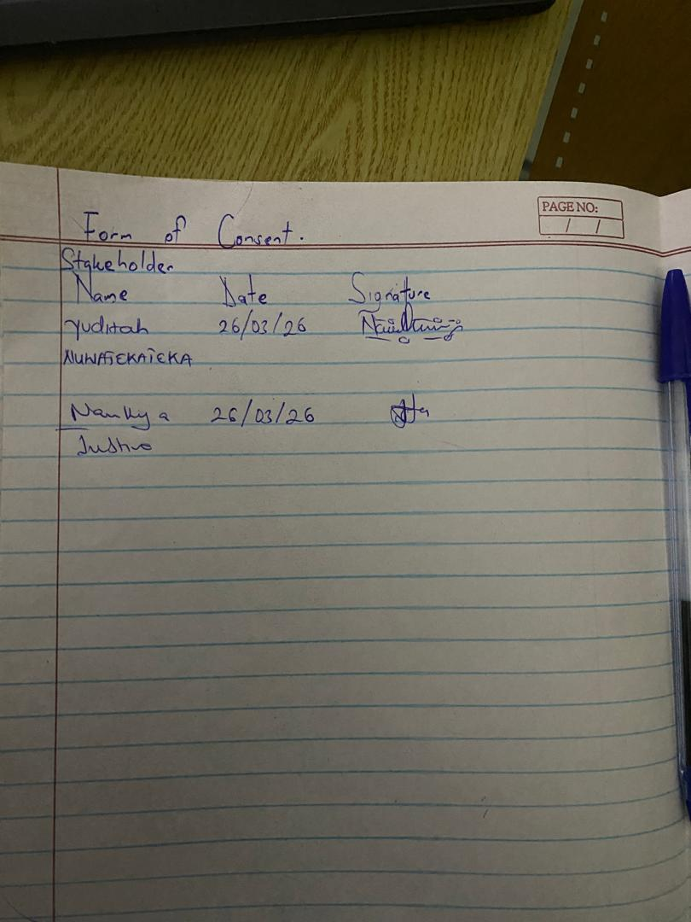
Figure 1: signatures from stakeholders.

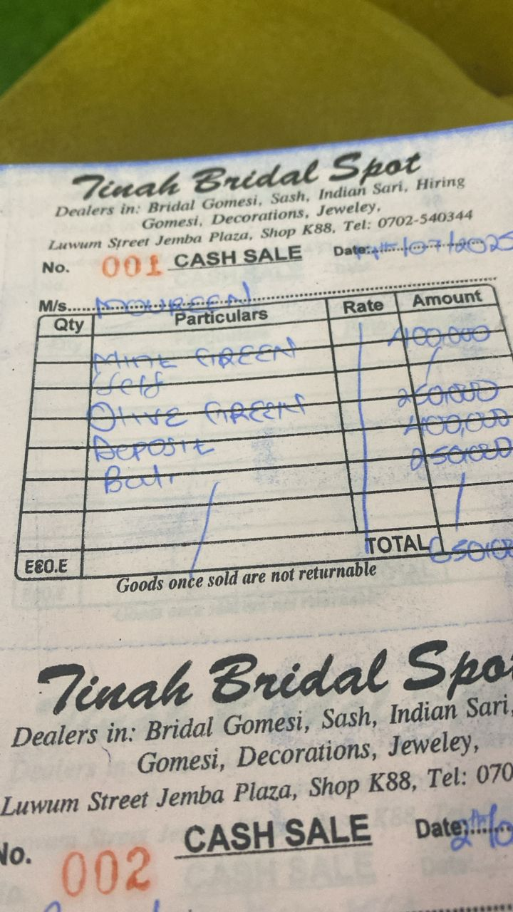
Figure 2: Physical receipt in use at Tinah Bridal Spot

